Asa Hayes

GEOG-352-502

Lab 4: GPS Unit Basics

Part 1: Navigating with GPS

|  |  |  |
| --- | --- | --- |
|  | Coordinates | Feature |
| 1 | 30.619180°, -96.339286° | Oil Pole/”Roughneck” Statue |
| 2 | 30.618758°, -96.340097° | Halbouty Geosciences Building, front-right entrance |
| 3 | 30.617666°, -96.340632° | H20 Fountain |
| 4 | 30.615504°, -96.341198° | Sul Ross Statue |
| 5 | 30.614111°, -96.338374° | 9/11 Memorial |

Part 2: Tree Hugging Survey

DNRGPS Point Table

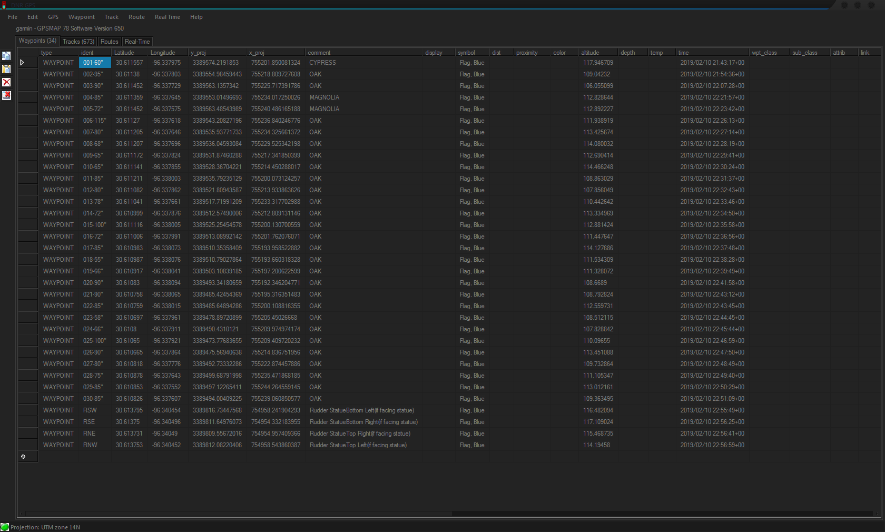

Google Maps Display of Points

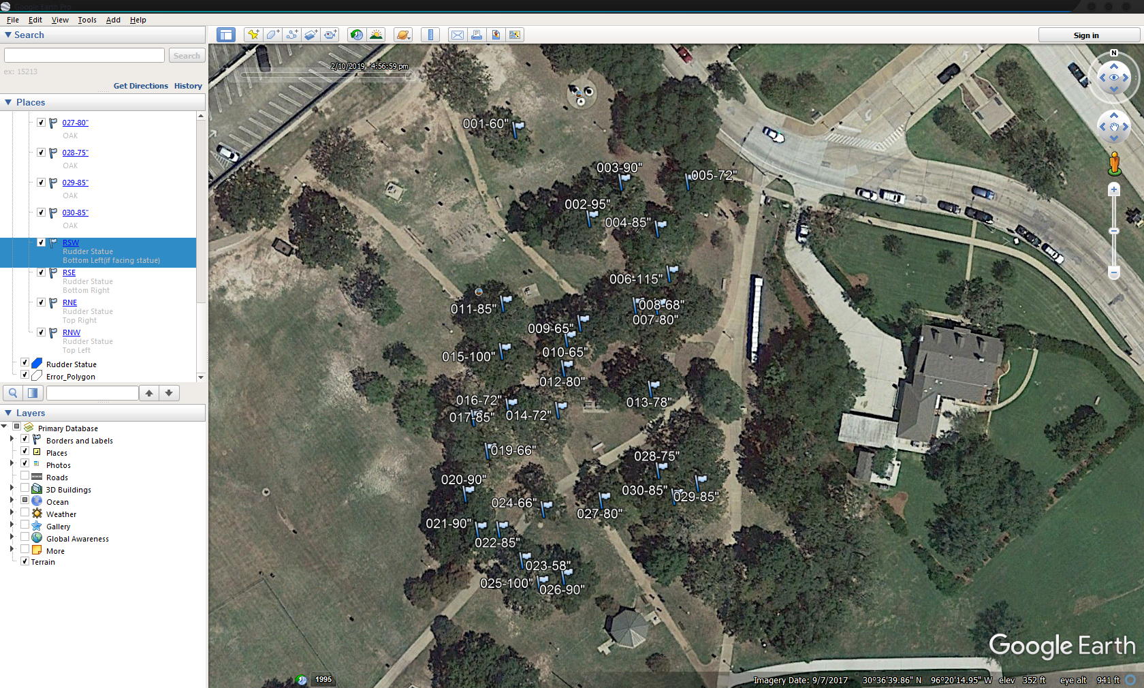

Part 3: Measure a Feature

Note: Despite ensuring that WAAS was enabled and giving a few seconds for correction at each point, the readings at each coordinate are off by several feet consistent neither in distance nor direction. Both the correct (blue) and incorrect (red) polygons have been shown. I would like to talk about what might have caused it to do this so that issues like this don’t come up in later labs.

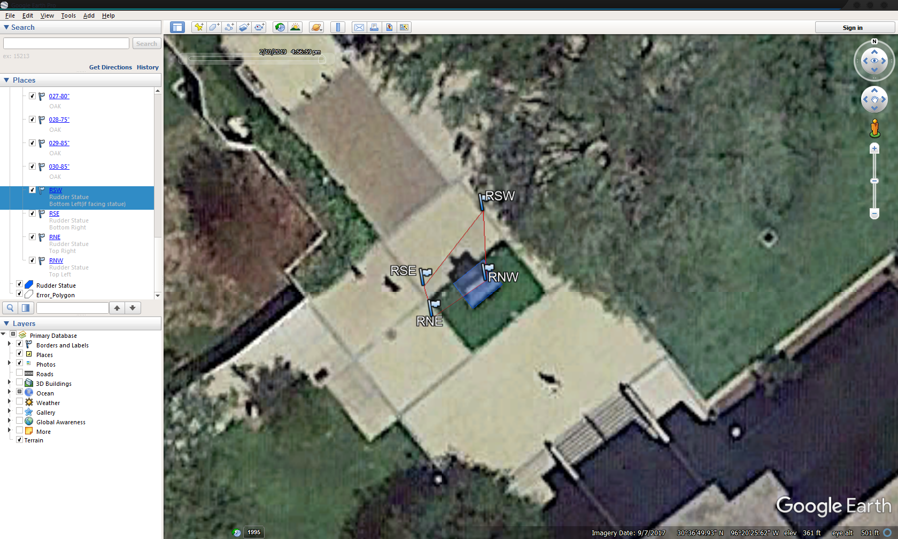

Part 4: ArcGIS Online

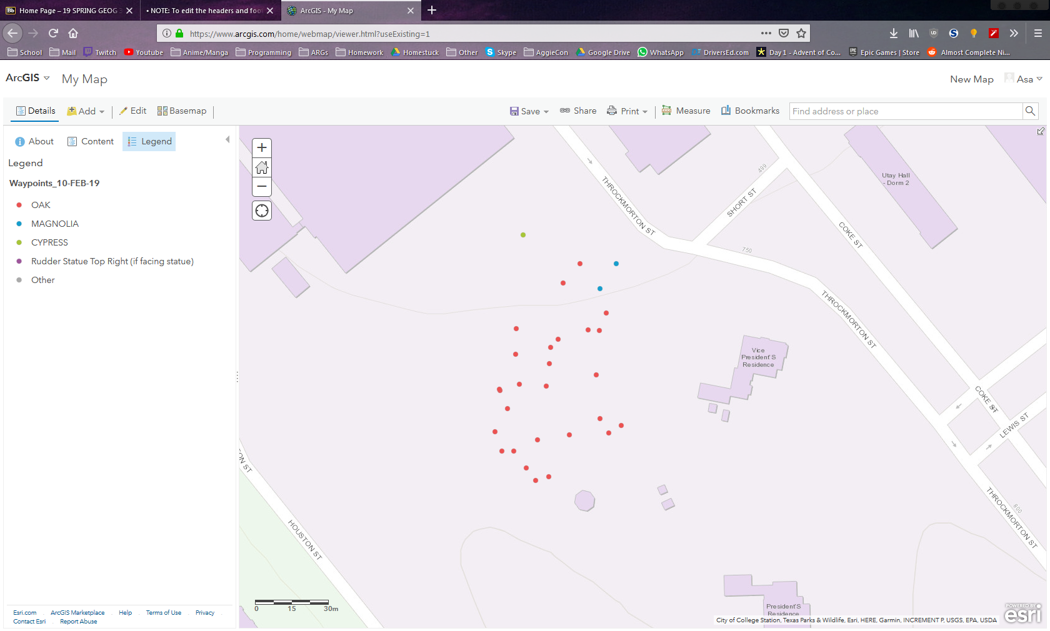

5: Bonus Questions

a) The three components of the GPS are the 24 satellites in the space segment, which broadcast their position to the user segment, which can calculate position on Earth based on them due to the efforts of the control segment, which maintains the datasets and satellites to ensure the GPS keeps working as a whole. While there are 24 satellites in the current constellation, only 4 of them at any given time are needed for precise positioning.

b) While the absolute minimum number of geroreference points is three, as that is the smallest number of points that can create an enclosing polygon and can have triangulation applied, it is recommended to have 4-5 at minimum, and more for more complex referenced areas.